Section 18.1 Electromagnetic Waves
© Pearson Education, Inc., publishing as Pearson Prentice Hall. All rights reserved.
(pages 532–538)
This section describes the characteristics of electromagnetic waves.

Reading Strategy _{(page} ₅₃₂₎
Comparing and Contrasting As you read about electromagnetic waves, fill in the table below. If the characteristic listed in the table describes electromagnetic waves, write E in the column for Wave Type. Write M for mechanical waves and B for both. For more information on this Reading Strategy, see the Reading and Study Skills in the Skills and Reference Handbook at the end of your textbook.

Electromagnetic and Mechanical Waves
Travels through a vacuum | E
Travels though medium
Fits wave model | B
Fits particle model
Transverse wave
Longitudinal wave

What Are Electromagnetic Waves? _{(page} ₅₃₃₎
- What are electromagnetic waves?

- Electric fields are produced by electrically charged particles and by changing .
- Magnetic fields are produced by magnets, by changing
, and by vibrating charges.
- Electromagnetic waves are produced when a(n)
vibrates or accelerates.
- Circle the letter of each sentence that is true about electric and magnetic fields.
  - An electromagnetic wave occurs when electric and magnetic fields vibrate at right angles to each other.
  - A magnetic field is surrounded by an electric current.
  - Changing electric and magnetic fields regenerate each other.
  - Electromagnetic waves are produced when an electric charge vibrates.
- Is the following sentence true or false? Electromagnetic waves need a medium to travel through.
- The transfer of energy by electromagnetic waves traveling through matter or across space is called radiation .

Physical Science Reading and Study Workbook ■ Chapter 18 211

The Speed of Electromagnetic Waves _{(page} ₅₃₄₎
- As a thunderstorm approaches, you see the lightning before
you hear the thunder, because light travels faster
than sound.
- Is the following sentence true or false? All electromagnetic waves travel at the same speed through a vacuum.
- Circle the letter that gives the correct speed of light in a vacuum.
  - 3.00 108 kilometers per second
  - 3.00 108 meters per hour
  - 3.00 108 meters per second
  - 3.00 108 kilometers per hour

Wavelength and Frequency _{(page} ₅₃₅₎
- Circle the letter of each sentence that is true about electromagnetic waves.
  - Different electromagnetic waves can have different frequencies.
  - Wavelength is directly proportional to frequency.
  - Electromagnetic waves always travel at the speed of light.
  - All electromagnetic waves travel at the same speed in a vacuum.
- As the wavelengths of electromagnetic waves increase, the frequencies , for waves moving in a(n) .
© Pearson Education, Inc., publishing as Pearson Prentice Hall. All rights reserved.

Wave or Particle? _{(pages} _{536–537)}
- Electromagnetic radiation behaves sometimes like a(n)
and sometimes like a stream of .
- Interference only occurs when two or more waves overlap, so
experiment showed that light behaves like a .
- The emission of electrons from a metal caused by light striking the metal is called the effect.
- Blue light has a higher frequency than red light, so photons of blue light have energy than photons of red light.
Intensity (page 538)
- The closer you get to a source of light, the the light appears.
- Intensity is the at which a wave’s energy flows through a given unit of area.
- As photons travel farther from the source, the of light decreases.

212 Physical Science Reading and Study Workbook ■ Chapter 18
Section 18.2 The Electromagnetic Spectrum
© Pearson Education, Inc., publishing as Pearson Prentice Hall. All rights reserved.
(pages 539–545)
This section identifies the waves in the electromagnetic spectrum and describes their uses.

Reading Strategy _{(page} ₅₃₉₎
Summarizing Complete the table for the electromagnetic spectrum. List at least two uses for each kind of wave. For more information on this Reading Strategy, see the Reading and Study Skills in the Skills and Reference Handbook at the end of your textbook.

The Electromagnetic Spectrum
Type  of Waves | Uses
Radio Waves | Communications
Infrared Rays |  | Keeping food warm

The Waves of the Spectrum _{(pages} _{539–540)}
- Is the following sentence true or false? William Herschel determined that the temperature of colors of light was higher at the blue end and lower at the red end.
- Herschel’s curiosity led him to conclude there must be invisible
beyond the red end of the color band.
- Is the following sentence true or false? The full range of frequencies of electromagnetic radiation is called the electromagnetic spectrum.

- Name each kind of wave in the electromagnetic spectrum, from the longest to shortest wavelength.
a. b.
c. d.
e. f.
Physical Science Reading and Study Workbook ■ Chapter 18 213

Radio Waves (pages 540–542)
- Circle the letter of each way that radio waves might be used.
a. X-ray machines b. microwave ovens
c. radio technology d. television technology
- What is the difference between amplitude modulation (AM)
and frequency modulation (FM)?

- How far do microwaves generally penetrate food?

- How is the Doppler effect used to detect the speed of a vehicle?

Infrared Rays _{(page} ₅₄₃₎
- Circle the letter of each way infrared rays are used.
a. source of light b. to discover areas of heat differences
c. source of heat d. to discover areas of depth differences
- Thermograms show variations in and are used to find places where a building loses heat to the environment.

Visible Light _{(page} ₅₄₃₎
- Is the following sentence true or false? One use for visible light is to help people communicate with one another.
© Pearson Education, Inc., publishing as Pearson Prentice Hall. All rights reserved.

Ultraviolet Rays _{(page} ₅₄₄₎
- Ultraviolet radiation has applications in and
.
- Is the following sentence true or false? Ultraviolet radiation helps your skin produce vitamin D.
X-rays (page 544)
- Is the following sentence true or false? X-rays have higher frequencies than ultraviolet rays. true
- Why are X-rays helpful?

Gamma Rays (page 545)
- Gamma rays have the highest and therefore the most and the greatest penetrating ability of all the electromagnetic waves.
- How is gamma radiation used in medicine?

214 Physical Science Reading and Study Workbook ■ Chapter 18

Section 18.3 Behavior of Light
(pages 546-549)
This section discusses the behavior of light when it strikes different types of materials.

Reading Strategy _{(page} ₅₄₆₎
Monitoring Your Understanding As you read, complete the flowchart to show how different materials affect light. For more information on this Reading Strategy, see the Reading and Study Skills in the Skills and Reference Handbook at the end of your textbook.
Light and Materials
Materials can be

Transparent
and an example of each is

Wood

Light and Materials _{(pages} _{546–547)}
- Is the following sentence true or false? Without light, nothing is visible.
Match each term to its definition.
Term Definition

2. transparent
3. opaque
4. translucent
  - Material that absorbs or reflects all of the light that strikes it
  - Material that transmits light
  - Material that scatters light

© Pearson Education, Inc., publishing as Pearson Prentice Hall. All rights reserved.

Interactions of Light _{(pages} _{547–549)}
- Is the following sentence true or false? Just as light can affect matter, matter can affect light.
- When light strikes a new medium, it can be ,
, or .

Physical Science Reading and Study Workbook ■ Chapter 18 215

- When light is transmitted, it can be refracted, polarized, or
scatter .
- A copy of an object formed by reflected or refracted light waves is known as a(n) .
- When parallel light waves strike an uneven surface and reflect off it in the same direction, reflection occurs.
- When parallel light waves strike a rough, uneven surface and reflect in many different directions, reflection occurs.
- Light bends, or , when it passes at an angle from one type of medium into another.
- Explain why a mirage occurs.

- Is the following sentence true or false? Light with waves that vibrate in only one plane is polarized light.
rizing
Vertical polarizing filter
Horizontal pola
filter

- Refer to the drawing and complete the table on polarizing filters.
© Pearson Education, Inc., publishing as Pearson Prentice Hall. All rights reserved.

Polarizing Filters
Direction of Light Vibration | Filter Type | Action
Horizontal wave | Vertically polarizing filter
 | Vertically polarizing filter | Light passes through.

- How do sunglasses block glare?

- The effect when light is redirected as it passes through a medium is called .
- Explain why the sun looks red at sunset and sunrise.

216 Physical Science Reading and Study Workbook ■ Chapter 18

Section 18.4 Color
© Pearson Education, Inc., publishing as Pearson Prentice Hall. All rights reserved.
(pages 550–553)
This section explains how a prism separates white light. It also discusses factors that influence the various properties of color.

Reading Strategy _{(page} ₅₅₀₎
Venn Diagram As you read, label the Venn diagram for mixing primary colors of light. For more information on this Reading Strategy, see the Reading and Study Skills in the Skills and Reference Handbook at the end of your textbook.
Mixing Colors of Light
Red
White
Green

Separating White Light Into Colors _{(page} ₅₅₁₎
1. What did Isaac Newton’s experiments with a prism in 1666 show?

2. What happens when white light passes through a prism?

3. Circle the letter of the process in which white light is separated into the colors of the rainbow.
a. reflection b. dispersion
c. absorption d. polarization
4. How does a rainbow form?

Physical Science Reading and Study Workbook ■ Chapter 18 217

The Colors of Objects _{(pages} _{551–552)}
- List two factors that determine the color of an object seen by reflected light.

- Is the following sentence true or false? I see a red car in sunlight because the color of light reaching my eyes is mostly red light.

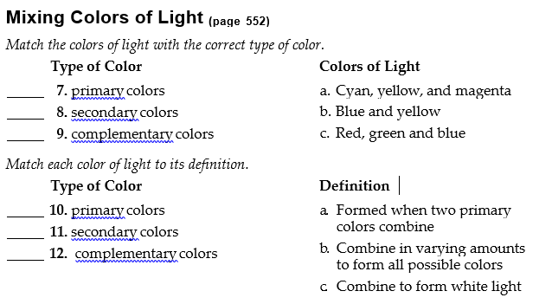
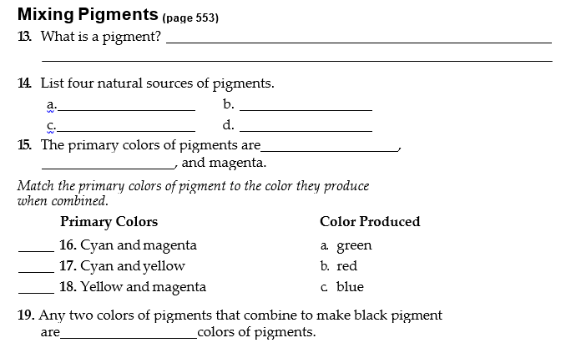

Section 18.5 Sources of Light
© Pearson Education, Inc., publishing as Pearson Prentice Hall. All rights reserved.
(pages 558–562)
This section discusses the major sources of light and their uses.

Reading Strategy _{(page} ₅₅₈₎
Flowchart Complete the incandescent bulb flowchart. For more information on this Reading Strategy, see the Reading and Study Skills in the Skills and Reference Handbook at the end of your textbook.
Incandescent Bulb
Electrons flow through filament.
Filament radiates light.

- Objects that give off their own light are .
- List six common sources of light.
a. b.
c. d.
e. f.

Incandescent Light _{(page} ₅₅₈₎
- The light produced when an object gets hot enough to glow is
.
- As electrons flow through an incandescent light bulb, the
heats up.
- Is the following sentence true or false? To increase the life of the filament, incandescent light bulbs contain oxygen at very low pressure.
- Most of the energy given off by incandescent bulbs is in the form of .

Fluorescent Light _{(page} ₅₅₉₎
- What happens in the process of fluorescence?

- A solid material that can emit light by fluorescence is called a(n)
.
- Fluorescent bulbs emit most of their energy in the form of
.
- Is the following sentence true or false? Incandescent bulbs are more energy efficient than fluorescent bulbs.

Physical Science Reading and Study Workbook ■ Chapter 18 219

Laser Light _{(page} ₅₆₀₎
- A laser is a device that generates .
- The letters in the word laser stand for l
a s e r .
- What is coherent light?

- Why does coherent light have a relatively constant intensity?

Neon Light (page 561)
- How is neon light emitted?

- List three gases used to produce neon light.

- Why do different types of neon light glow in different colors?
© Pearson Education, Inc., publishing as Pearson Prentice Hall. All rights reserved.

Sodium-Vapor Light _{(page} ₅₆₂₎
- Sodium-vapor lights contain a mixture of and a small amount of solid .
- Explain what happens when an electric current passes through a
sodium-vapor bulb. which

Tungsten-Halogen Light _{(page} ₅₆₂₎
- Explain how a tungsten-halogen light bulb works.

