Section 20.1 Electric Charge and Static Electricity
© Pearson Education, Inc., publishing as Pearson Prentice Hall. All rights reserved.
(pages 600–603)
This section explains how electric charge is created and how positive and negative charges affect each other. It also discusses the different ways that electric charge can be transferred.

Reading Strategy _{(page} ₆₀₀₎
Identifying Main Ideas Copy the table on a separate sheet of paper. As you read, write the main ideas. For more information on this Reading Strategy, see the Reading and Study Skills in the Skills and Reference Handbook at the end of your textbook.

Characteristics of Electric Charge
Topic | Main Idea
Electric Charge | An excess or shortage of electrons produces a net electric charge.
Electric Forces
Electric Fields
Static Electricity

Electric Charge (pages 600–601)
- What are the two types of electric charge?
a. b.
- Is the following sentence true or false? In an atom, negatively charged electrons surround a positively charged nucleus.

- Is the following sentence true or false? If a neutral atom gains one or more electrons, it becomes a positively charged ion.

- What is the SI unit of electric charge?

Electric Forces _{(page} ₆₀₁₎
- Circle the letter of each sentence that is true about electric force.
  - Like charges attract and opposite charges repel.
  - Electric force is the attraction or repulsion between electrically charged objects.
  - Electric force is inversely proportional to the amount of charge.
  - Electric force is inversely proportional to the square of the distance between two charges.
Physical Science Reading and Study Workbook ■ Chapter 20 239

- Which are stronger inside an atom, electric forces or gravitational forces?
- Is the following sentence true or false? Electric forces cause friction and other contact forces.

Electric Fields _{(page} ₆₀₂₎
- A charge’s electric field is the effect the charge has on
in the space around it.
- Circle the letters of the factors that the strength of an electric field depends on.
  - the direction of the field
  - whether the charge is positive or negative
  - the amount of charge that produces the field
  - the distance from the charge
- Is the following sentence true or false? The field of a negative charge points away from the charge.

Static Electricity and Charging _{(pages} _{602–603)}
- Static electricity is the study of the .
- Is the following sentence true or false? Charge can be transferred by friction, by contact, and by induction.
- What is the law of conservation of charge?

- Rubbing a balloon on your hair is an example of charging by
.
© Pearson Education, Inc., publishing as Pearson Prentice Hall. All rights reserved.
- A charge transfer between objects that touch each other is called
.
- Circle the letter of each sentence that is true about charging.
  - When you rub a balloon on your hair, your hair loses electrons and becomes positively charged.
  - The sphere of a Van de Graaff generator transfers all of its charge to you when you touch it.
  - Induction occurs when charge is transferred without contact between materials.
  - Static charges cannot move.

Static Discharge _{(page} ₆₀₃₎
- Is the following sentence true or false? Static discharge occurs when a pathway through which charges can move forms suddenly.
- How does lightning occur?

240 Physical Science Reading and Study Workbook ■ Chapter 20

Section 20.2 Electric Current and Ohm’s Law
© Pearson Education, Inc., publishing as Pearson Prentice Hall. All rights reserved.
(pages 604–607)
This section discusses electric current, resistance, and voltage. It also uses Ohm’s Law to explain how voltage, current, and resistance are related.

Reading Strategy _{(page} ₆₀₄₎
Predicting Before you read, write a prediction of what electric current is in the table below. After you read, if your prediction was incorrect or incomplete, write what electric current actually is. For more information on this Reading Strategy, see the Reading and Study Skills in the Skills and Reference Handbook at the end of your textbook.

Electric Current
Electric Current Probably Means | Electric Current Actually Means

Electric Current _{(page} ₆₀₄₎
- What is electric current?

- Complete the following table about electric current.

Electric Current
Type of Current | How Charge Flows | Examples
Direct
Alternating | Two directions

- Electrons flow in the wire from a(n) terminal to a(n) terminal.

Conductors and Insulators _{(page} ₆₀₅₎
- What is an electrical conductor?

- What is an electrical insulator?

- Is the following sentence true or false? Metals are good conductors because they do not have freely moving electrons.

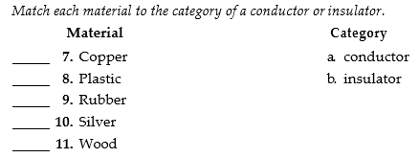
- Explain why the current is reduced as electrons move through
a conductor.

- Circle the letter of each factor that affects a material’s resistance.
a. its length b. its temperature
c. its velocity d. its thickness
- What is a superconductor?
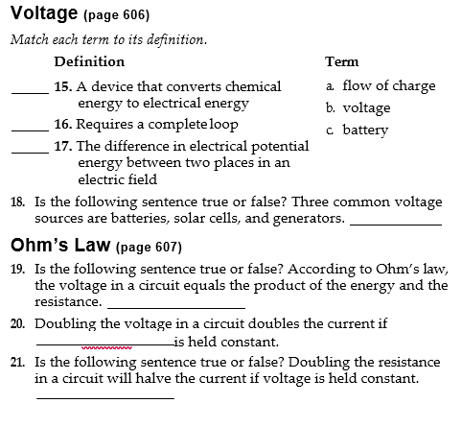

Section 20.3 Electric Circuits
© Pearson Education, Inc., publishing as Pearson Prentice Hall. All rights reserved.
(pages 609–613)
This section describes circuit diagrams and types of circuits. It also explains calculation of electric power and electric energy and discusses electrical safety.

Reading Strategy _{(page} ₆₀₉₎
Relating Text and Visuals As you read about household circuits, complete the table by listing three things the diagram in Figure 13 helps you understand about circuits. For more information on this Reading Strategy, see the Reading and Study Skills in the Skills and Reference Handbook at the end of your textbook.

Understanding a Circuit Diagram
What Can Be Seen in the Circuit Diagram?
Wire bringing current from outside

Circuit Diagrams _{(pages} _{609–610)}
1. Circuit diagrams use to represent parts of a circuit, including a source of electrical energy and devices that are run by the electrical energy.
Match each symbol to what it indicates on a circuit diagram.
 | Symbol | What Symbol Indicates
 | 2. | a. The direction of current
 | 3. - | b. A negative terminal
 | 4. | c. A positive terminal

Series Circuits _{(page} ₆₁₀₎
- Is the following sentence true or false? In a series circuit, if one element stops functioning, then none of the elements can operate.
true
- Explain why the bulbs shine less brightly when more bulbs
are added to a series circuit.

Parallel Circuits _{(page} ₆₁₀₎
- Is the following sentence true or false? Circuits in a home are rarely wired in parallel.
- If one element stops functioning in a parallel circuit, the rest of the elements operate .

Power and Energy Calculations _{(pages} _{611–612)}
- The rate at which electrical energy is converted to another form of energy is called .
- The SI unit of electric power is the joule per second, or
, which is abbreviated .
- Is the following sentence true or false? Electric power is calculated by multiplying current times voltage.
- Write the formula for calculating electrical energy.

- The unit of energy usually used by electric power companies is the
.

Electrical Safety _{(pages} _{612–613)}
- Circle the letters of what could happen if the current in a wire exceeds the circuit’s safety limit.
a. The wire could overheat. b. The wire could get cooler.
c. A fire could start. d. A fuse could blow.
- Explain how a fuse prevents current overload in a circuit.

- A switch that opens to prevent overloads when current in a circuit is too high is called a(n) .
- Explain why touching an electrical device with wet hands
is dangerous.
© Pearson Education, Inc., publishing as Pearson Prentice Hall. All rights reserved.

- Is the following sentence true or false? A ground-fault circuit interrupter shuts down the circuit if the current flowing through the circuit and current returning to ground are equal.

- The transfer of excess charge through a conductor to Earth is called
.
- Complete the following table about equipment used to prevent electrical accidents.

Equipment to Prevent Current Overload | Equipment to Protect People from Shock | Equipment to Prevent Short Circuits
a. | b. | e.
Circuit breaker | c.
 | Grounding wire
 | d.

Section 20.4 Electronic Devices
(pages 618–622)
This section discusses how various electronic devices operate and what they are used for.

Reading Strategy _{(page} ₆₁₈₎
Summarizing Copy the table on a separate sheet of paper. As you read, complete the table to summarize what you learned about solid- state components. For more information on this Reading Strategy, see the Reading and Study Skills in the Skills and Reference Handbook at the end of your textbook.

Solid–State Components
Solid-State Component | Description | Uses
Diode
Transistor
Integrated Circuit
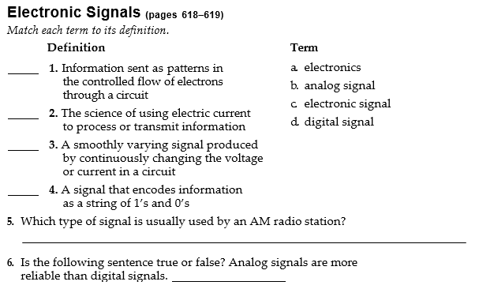

Vacuum Tubes _{(page} ₆₁₉₎
5. Circle the letter of each item that is true about vacuum tubes.
  - can change alternating current to direct current
  - never burn out
  - can increase the strength of a signal
  - can turn a current on or off
- Is the following sentence true or false? An image is produced in a CRT when phosphors glow red, green, and blue in response to electron beams.

Semiconductors _{(page} ₆₂₁₎
7. What is a semiconductor?

8, Name the two types of semiconductors.
a. b.
- Circle the letter of each sentence that is true about a p-type semiconductor.
  - It can be made by adding a trace amount of boron to a silicon.
  - Electrons are attracted to positively charged holes at each boron atom.
  - As the electrons jump from hole to hole, it looks like a flow of positive charge.
  - Boron atoms provide weakly bound electrons that can flow.
© Pearson Education, Inc., publishing as Pearson Prentice Hall. All rights reserved.
- Is the following sentence true or false? In an n-type semiconductor, weakly bound electrons can conduct a current.
