Galaxy Classification Lab
Objectives:
- Contrasting the different types of galaxies.
- Exploring the shapes of galaxies.
Vocabulary:
- galaxy
- gravitational attraction
- light year
- stars
- barred-spiral
- irregular
- spiral
Materials:
- galaxy pictures
- galaxy background
- galaxy identification chart
- pen/pencil
Procedures:
- Students will work in small groups to read background information about galaxies.
- Students will then answer some follow up questions as a small group.
- Students will complete the galaxy classification activity using pictures and graphic organizer.
References:
Galaxy Background:
https://southlakeearthscience.weebly.com/chapter-26-notes.html

GALAXY BACKGROUND:
A galaxy is a large collection of stars, dust, and nebulae (gas clouds) which are held together by gravitational attraction. The amount of space that these galaxies take up is immense. They are measured in light years (the distance that light travels in one year, about 9.4 trillion km). It is difficult, if not impossible, to accurately measure the distances to galaxies. The Magellanic Clouds are 150,000–200,000light years from the Milky Way, and have a diameter of 30,000 light years. The Andromeda Galaxy is 870,000 light years away, and has a diameter of 45,000 light years. Our own galaxy is estimated to be 100,000 light years in diameter with a height of 10,000 light years at the bulge, but this changes depending on the astronomer who does the measurements.

More than 100 ball shaped clusters of stars, called globular clusters, surround the Milky Way. These globular clusters appear to be composed of very old stars. Their origin is unclear. Omega Centauri and 47 Tucanae are examples of clusters.

Edwin Hubble, a well known astronomer, classified galaxies into three major groups, ellipsoidal (elliptical), spiral, and irregular, based on their shape and origin. The core of a galaxy, where most of its stars are concentrated, is called the galaxy’s nucleus (bulge). The spiral arms of spiral galaxies are concentrations of stars that seem to spin from the nucleus.

Elliptical Galaxies- Symmetrical structures ranging from spheres to flattened ellipses. Usually these stars are older types of stars called Population II.

Spiral Galaxies- A galaxy that has a distinct nucleus and one or more spiral arms. The arms extend outward from the nucleus and are composed of stars, dust, and gas. Population I stars are found in the arms and Population II in the nucleus, between arms and probably in the halo. Population I are considered younger stars. There are 2 distinct classes of spirals:
- Normal Spiral
-Several arms radiate from center (top view)
- Barred Spiral
-Have elongated centers, called bars, with arms, coming from each end.

Irregular Galaxies-No regular shape, includes nebulas.

Elliptical galaxies seem to be more common than spiral galaxies, and tend to be composed of older stars. However, spiral galaxies contain more than 75% of the bright stars observed in the Universe. Irregular galaxies are rare, accounting for only 3% of known galaxies. There is some evidence that galaxies evolve in shape through time. However, this idea is currently hypothetical; given the short time span we have been able to observe galaxies.
Galaxy Identification Lab

Directions: In this lab, you will try to use pictures that are provided on the attached sheet to identify types of galaxies.

Problem: How are galaxies classified?

Prediction: ____________________________________________________________________________________________________________________________________________________________________________________________________________________________________________________________________________

Procedure:

Part I- Answer the following questions:
- Galaxies are a group of _________________________________.
- The galaxies stay together because ________________________________
__________________________________________________________.
- Galaxies are part of the _______________________________________.
- The four main types of galaxies are ______________________________
________________________________________________________.

Part II- Categorize the galaxies.
- Cut out the pictures.
- Try to categorize the pictures into the different types of galaxies.
- Glue the pictures into the appropriate column of your Galaxy Identification Chart.

Part III- Analysis
- Do you see any relationship between the shape of the galaxies and how they may have evolved? Look closely at the shapes. Explain your observations.
____________________________________________________________
____________________________________________________________
____________________________________________________________
____________________________________________________________
____________________________________________________________
____________________________________________________________

Part IV- Conclusion
Do all of the pictures of the galaxies fit into defined groups or do you think the classification of galaxies is “nebula” (unclear)? Justify your thoughts using the knowledge you have gained from this lab.
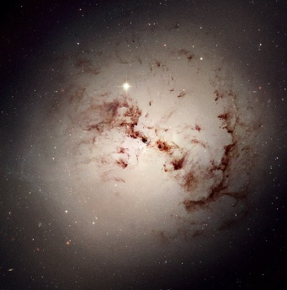  Picture A  Image courtesy of https://www.flickr.com/photos/scatcat/2098901195 | 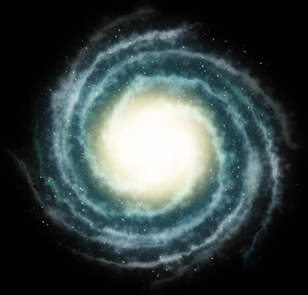  Picture B  image courtesy of http://coornio.deviantart.com/art/Galaxy-Spiral-192180270 | 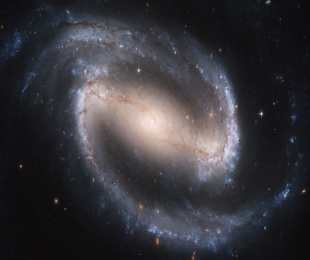  Picture C  Image courtesy of https://www.flickr.com/photos/56741427@N00/1809067871
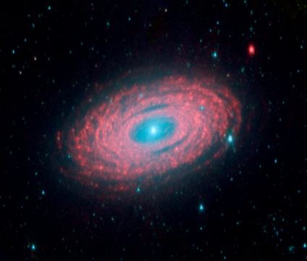  Picture D  Image courtesy of http://commons.wikimedia.org/wiki/File:Spiral_Galaxy_NGC_2841.jpg | 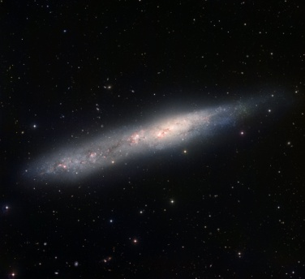  Picture E  Image courtesy of https://www.flickr.com/photos/nasamarshall/ | 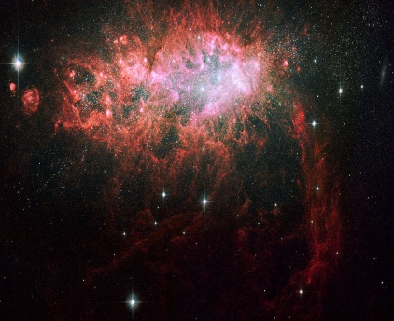  Picture F  Image courtesy of https://www.flickr.com/photos/hubble-heritage/3200167172/
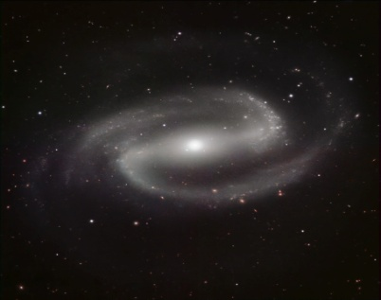  Picture G  Image courtesy of  http://en.wikipedia.org/wiki/NGC_1097 | 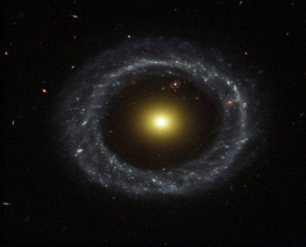  Picture H  Image courtesy of http://en.wikipedia.org/wiki/Galaxy | 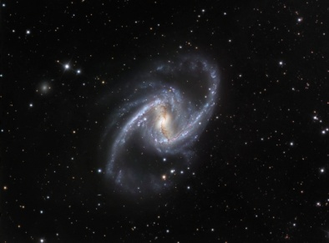  Picture I  image courtesy of https://www.flickr.com/photos/gsfc/3904169048
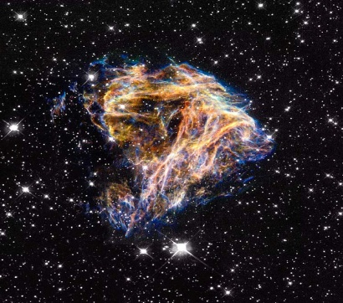  Picture J  Image courtesy of  https://www.flickr.com/photos/hubble-heritage/3194401148/ | 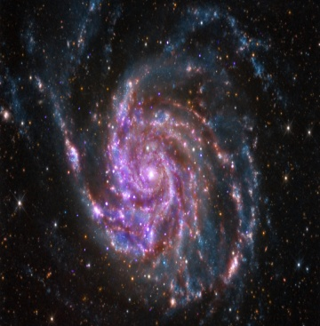  Picture K  Image courtesy of http://doomwillfindyou.deviantart.com/art/M33-Triangulum-Galaxy-HaLRGB-143771026 | 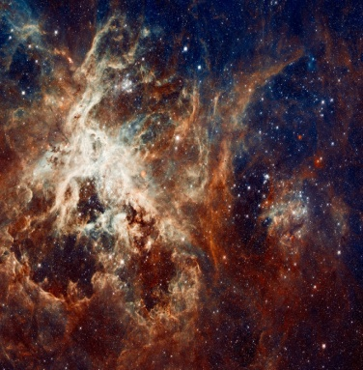  Picture L  Image courtesy of https://www.flickr.com/photos/scatcat/2098843707/

Spiral | Elliptical | Barred-Spiral | Irregular
Galaxy Identification Chart

